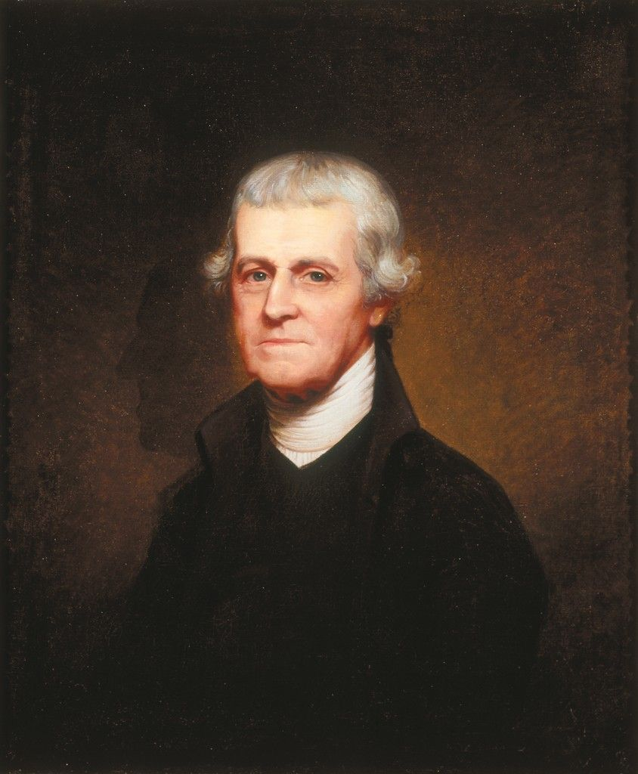**Noble Wimberly Jones**

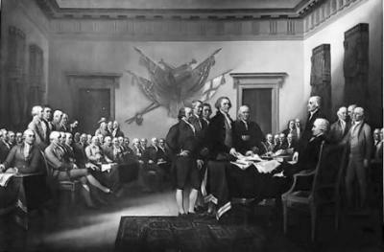

Please Answer While Reading the Article

1. Who was N.W.J.?
2. How many times was N.W.J. elected to the House of assembly?
3. Did Noble Jones attend any continental congress meetings?
4. What was N.W.J.’s main occupation?